Why Vaccinate?  About 14 million people, including teens, become infected with HPV each year. The good news is that you can get vaccinated against HPV and prevent cancer. Vaccines work! #HPVvaxNOW #OurMoment |  | Reminder  Remember to put HPV vaccine on your back-to-school checklist. Preteens need Tdap, HPV & meningococcal vaccines to get the best protection from serious, sometimes deadly, diseases. HPV vaccine protects against HPV-related cancers. Make an appointment to get your girls and boys the HPV vaccine today. |  | Quotes  “I want to protect my kids in every way that I can, and this is a very easy way to protect them against HPV; it's one less thing that I have to worry about.” Katie Fox is a South Carolina parent ambassador and an advocate in her community about the importance of HPV vaccination. |  | Motivation  Beat the rush and make an appointment for your girls and boys to get the HPV vaccine before they go back to school. HPV vaccine protects against HPV-related cancers. |  | INVEST Calendar  AUG  National Immunization  Awareness Month (NIAM)
Remember to share at least one social media message from each row with your
school community this month.
It's National Immunization awareness month! Get your middle schooler vaccinated.  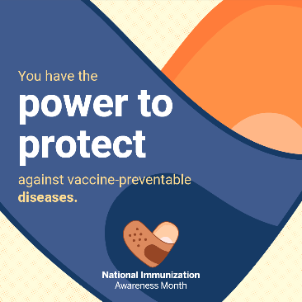 |  | Don't delay well child visits. It's safe to go to your medical provider. #CallYourPediatrician |  | Learn more how vaccines protect your middle schooler on https://www.hhs.gov/immunization/basics/work/prevention/index.html |  | Whooping cough affects people of all ages. Make sure your middle schooler is vaccinated.  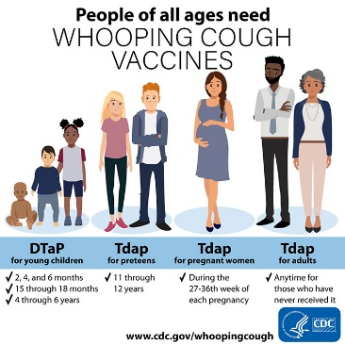 |  | 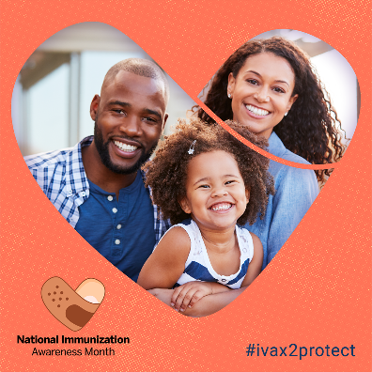

Why Vaccinate?  HPV vaccination today is cancer prevention for the future. Get vaccinated! Vaccinate your children! #2shots2stopCancer #HPVvaxNOW |  | Reminder  School supplies, check. New clothes, check. Vaccines? Have you crossed vaccines off your kids’ back-to-school checklist? Help your child live a long and happy life – Get your boys and girls the HPV vaccination. |  | Quotes  “We know that parents have the power to shape the future and we can prevent cancer by choosing the HPV vaccination.” Today’s #WCW is Beth Sundstrom, PhD, MPH. She explains the importance and the many benefits of the HPV vaccine here: https://vimeo.com/348266969 |  | Motivation  Parents: Don’t miss the chance to protect your children from 6 types of HPV-related cancer. Make sure they get two doses of the HPV vaccine at age 11 or 12 |  | INVEST Calendar  SEP  Children's Eye Health and Safety Month
Remember to share at least one social media message from each row with your
school community this month.
Vaccination protects yourself and others around you.  Learn more about community immunity on https://www.hhs.gov/immunization/basics/work/protection/index.html |  | DON'T FORGET – The required school vaccinations are due soon.  Schedule an appointment today and bring the updated vaccination form to the school nurse!  #CallYourPediatrician |  | Don’t skip vaccines – Protect your middle schooler from serious diseases!  #CallYourPediatrician |  | During the COVID pandemic, vaccination rates have declined significantly.  We all must work together to #KeepUpTheRates! www.nfid.org/KeepUpTheRates 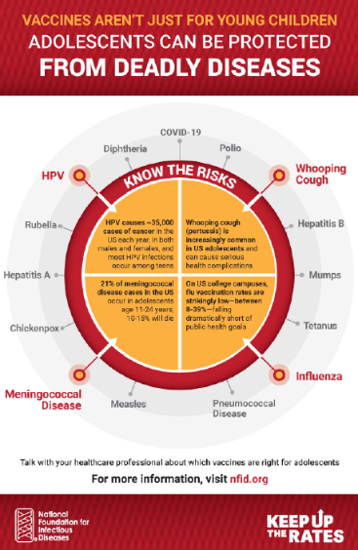 |  | 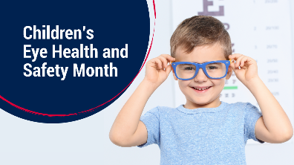

Why Vaccinate?  More evidence shows the HPV vaccine is effective and prevents cervical cancer. Researchers found that rates of infection with HPV and cervical pre-cancers declined significantly between 2008 and 2014. Click here to learn more about HPV vaccine’s safety and effectiveness: https://www.cdc.gov/vaccines/vpd/hpv/hcp/safety-effectiveness.html |  | Reminder  Most parents choose to get the HPV vaccine to protect their children from cancers caused by HPV infections. Are your kids protected? The human papillomavirus (HPV) vaccine protects against HPV infection, which is a common virus that can cause cancer. Make an appointment to get your girls and boys the HPV vaccine today. |  | Knowledge and Facts  The HPV vaccine is effective and long-lasting. A new study in Pediatrics found that the HPV vaccine is effective in preventing the spread of the virus over a 10-year period. Click here to learn more about HPV vaccine’s safety and effectiveness: https://www.cdc.gov/vaccines/vpd/hpv/hcp/safety-effectiveness.html |  | Motivation  Like all vaccines, scientists monitor the HPV vaccine over time to ensure it’s safe and effective. You can protect against 90% of HPV cancers by getting vaccinated. Click here to learn more about HPV vaccine’s safety and effectiveness: https://www.cdc.gov/vaccines/vpd/hpv/hcp/safety-effectiveness.html |  | INVEST Calendar  OCT  Children's Health Month
Remember to share at least one social media message from each row with your
school community this month.
Meningococcal disease is very serious. Protect your middle schooler through vaccination.  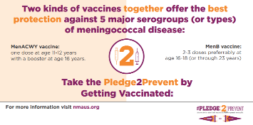 |  | During the #COVID pandemic, #vaccination rates have declined significantly, with demand plummeting as much as 95% for some vaccines. We are proud to support the #KeepUpTheRates campaign with @NFIDvaccines to raise awareness about the importance of routine vaccines for all individuals www.nfid.org/KeepUpTheRates 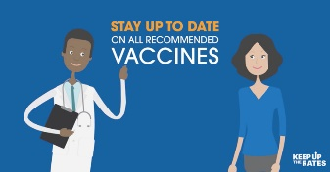 |  | Did your middle schooler get their flu vaccine yet?  Roll your Sleeve Up for your annual flu vaccine. Find a flu vaccine near you: https://www.vaccinefinder.org  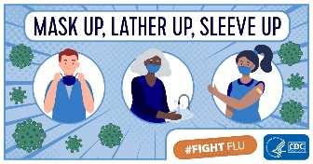 |  | COVID-19 vaccination helps keep you from getting COVID-19.  The vaccines currently available in the United States are effective at preventing COVID-19, and are important tools to stop the pandemic.  Learn more: https://www.cdc.gov/coronavirus/2019-ncov/vaccines/vaccine-benefits.html 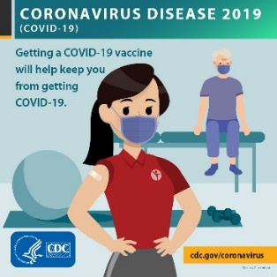 |  | 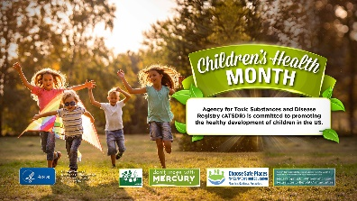

HPV – Post #1 |  | HPV – Post #2 |  | HPV – Post #3 |  | HPV – Post #4
The earlier your middle schooler gets the HPV vaccine, the sooner they are protected from six types of cancer.  Michelle Whitlock, a cancer survivor, talks about the importance of HPV vaccination: https://www.youtube.com/watch?v=Q7dnAo2rgSc&t=4s |  | Prevent six types of cancers – Get your middle schooler vaccinated against HPV at ages 11 or 12!  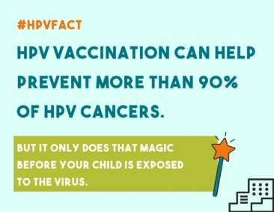 |  | Get your middle schooler the HPV vaccine at ages 11 or 12 to prevent six types of cancer! |  | Many people who have HPV infection do not know it until later when they develop cancer. Get your middle schooler vaccinated today to prevent HPV infection and cancer.  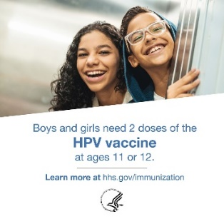 |  | INVEST Calendar  NOV  One Health Day
Remember to share at least one social media message from each row with your
school community this month.
Other vaccine – Post #1 |  | Other vaccine – Post #2 |  | Other vaccine – Post #3 |  | Other vaccine – Post #4
Why do you need to get a flu vaccine every year?  First, flu viruses change, so the vaccine is updated to keep up with changing flu viruses. Second, your immune protection from the vaccine declines over time.  Stay protected and get vaccinated now! #FightFlu https://www.cdc.gov/flu  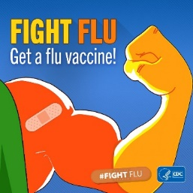 |  | Vaccines help you protect your middle schooler against harmful diseases. Make sure they are fully vaccinated!  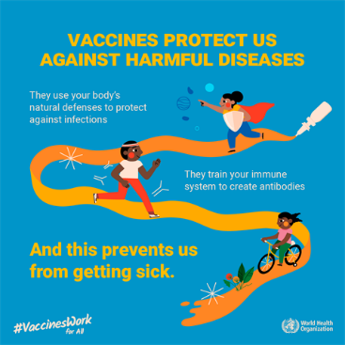 |  | Are your middle schoolers up to date on recommended vaccines? Along with a yearly flu vaccine, all 11-12-year-olds should get three vaccines to protect against meningitis, cancers caused by HPV infections, and whooping cough. https://go.usa.gov/xyPFR |  | Meningococcal vaccines help protect against the bacteria that cause meningococcal disease. Talk to your middle schooler’s doctor or nurse about meningococcal vaccines, or visit www.cdc.gov/meningococcal/vaccine-info.html  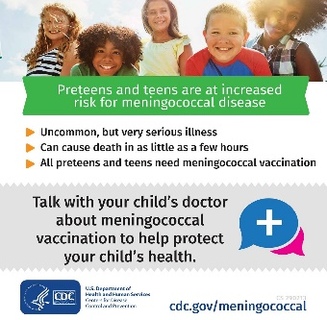 |  | 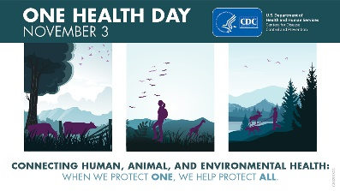

HPV – Post #1 |  | HPV – Post #2 |  | HPV – Post #3 |  | HPV – Post #4
Check out this @HPVRoundtable video, “Going Viral: Conversations on HPV Disease Prevention” with Kristin Oliver, Pediatrician at Mount Sinai, who explains why American Academy of Pediatrics (AAP) recommends the HPV vaccine for your middle schooler. https://www.youtube.com/watch?v=ke5Gheqr1i4 |  | The HPV vaccine (shots) prevents infection with the most harmful kinds of HPV. A decade of studies has shown that the HPV vaccine is safe for middle schoolers and effective at preventing six types of cancer. Click here to learn more about HPV vaccine’s safety and effectiveness: https://www.cdc.gov/vaccines/vpd/hpv/hcp/safety-effectiveness.html |  | Young cervical cancer survivor in South Carolina underscores the importance of the HPV vaccine. “The vaccine is one thing I never got,” said Halea Wylie. “I didn’t think it was one of those vaccines that was really needed because it wasn’t pushed that hard back when it first came out. Now, doctors really stress the need for it, and some parents might not understand why, but it’s very important.” Click here to watch her story: https://bit.ly/2R43EO8 |  | There are many myths and misunderstandings about HPV and cervical cancer. Check out the National Cervical Cancer Coalition’s FACTS about cervical cancer and prevention by clicking here: https://bit.ly/3eEkMmw |  | INVEST Calendar  DEC  National Influenza (Flu) Vaccination Awareness Week (December 6-12)
Remember to share at least one social media message from each row with your
school community this month.
Other vaccine – Post #1 |  | Other vaccine – Post #2 |  | Other vaccine – Post #3 |  | Other vaccine – Post #4
Did you know? It’s National Influenza Vaccination Week, a reminder that there’s still time to get vaccinated. When more people are protected against flu, it is less likely to spread. To learn more about benefits of flu vaccination visit: https://www.cdc.gov/flu/prevent/vaccine-benefits.htm  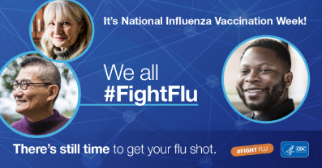 |  | The more people vaccinated against #flu, the more people protected from flu. Learn more: cdc.gov/flu  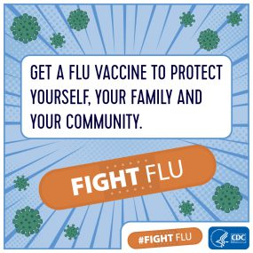 |  | #VaccinesWork! Take action today - Get your middle schooler fully vaccinated!  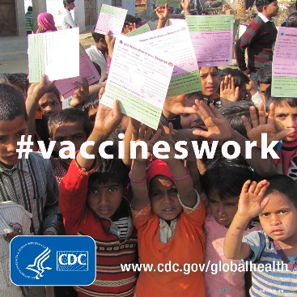 |  | Did you know? In the United States, a number of safeguards are required by law to help ensure that the vaccines we receive are safe. Learn more: https://www.cdc.gov/patientsafety/features/vaccine-safety.html |  | 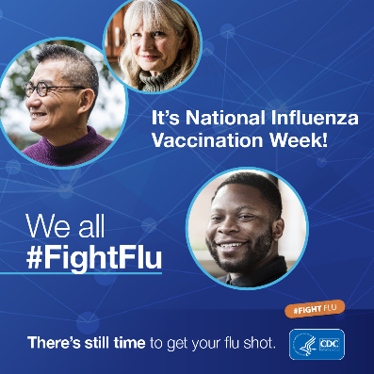

HPV – Post #1 |  | HPV – Post #2 |  | HPV – Post #3 |  | HPV – Post #4
HPV can cause cancers in men and women. Protect your middle schoolers now with the HPV vaccine.  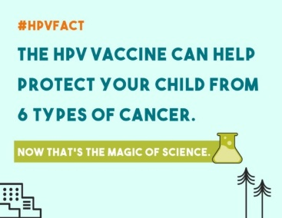 |  | Get your middle schooler the HPV vaccine at ages 11 or 12 to prevent six types of cancer!  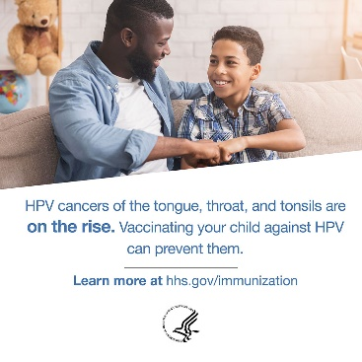 |  | Did you know? The HPV vaccine can be given to girls AND boys as early as age 9. The Advisory Committee on Immunization Practices (ACIP) recommends only 2 doses for girls and boys who start the shots before their 15th birthday. Click here to learn more about HPV vaccine: https://www.cdc.gov/vaccines/parents/diseases/hpv.html |  | Did you know? Men are 4 times more likely than women to get HPV cancers of the tongue, throat, and tonsils. Learn more about HPV and men: https://www.cdc.gov/std/hpv/stdfact-hpv-and-men.htm |  | INVEST Calendar  JAN  Cervical Health  Awareness Month
Remember to share at least one social media message from each row with your
school community this month.
Other vaccine – Post #1 |  | Other vaccine – Post #2 |  | Other vaccine – Post #3 |  | Other vaccine – Post #4 |  | 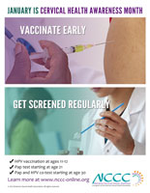
Do you know which vaccines are recommended for your middle schooler? Check out CDC’s interactive vaccine guide for families: https://www.cdc.gov/vaccines/growing/ |  | Learn more about the journey of a vaccine: https://www.cdc.gov/vaccines/parents/infographics/journey-of-child-vaccine-h.pdf |  | Any worries about the cost of vaccines? If your middle schooler is eligible, you can get vaccines for free through the Vaccines for Children program. Learn more about the program: https://www.cdc.gov/vaccines/programs/vfc/parents/index.html  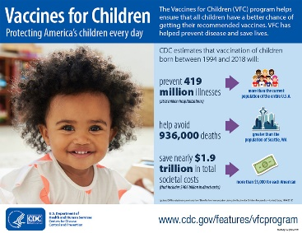 |  | Keep your family healthy through routine vaccines.  #CatchUpGetAhead  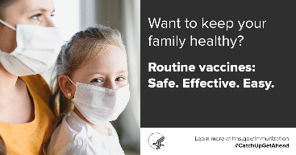

HPV – Post #1 |  | HPV – Post #2 |  | HPV – Post #3 |  | HPV – Post #4
Over 135 million doses of HPV vaccine have been distributed in the U.S. since the vaccine was introduced, and no serious side effects have been linked to HPV vaccination. The most common side effects after HPV vaccine are mild and include pain in the arm where the shot was given, fever, dizziness, and nausea. Click here to learn more about HPV vaccine safety: https://www.cdc.gov/vaccinesafety/vaccines/hpv-vaccine.html |  | Did you know? The HPV vaccine has been around for more than 15 years and there are ongoing monitoring efforts to ensure it’s safe for your middle schooler.  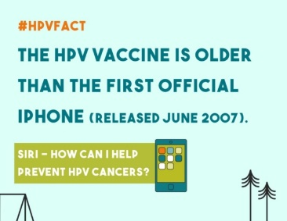 |  | The HPV vaccine has a strong record of safety — and it’s an effective way to protect your loved ones against HPV cancers. Click here to learn more about HPV vaccine safety: https://www.cdc.gov/vaccinesafety/vaccines/hpv-vaccine.html |  | The HPV vaccine is safe — The safety of HPV vaccine has been constantly monitored for over 15 years.  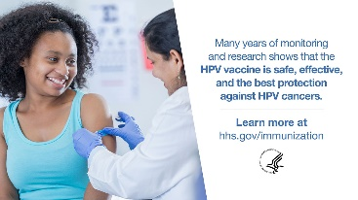 |  | INVEST Calendar  FEB  National Cancer  Prevention Month
Remember to share at least one social media message from each row with your
school community this month.
Other vaccine – Post #1 |  | Other vaccine – Post #2 |  | Other vaccine – Post #3 |  | Other vaccine – Post #4
Facts versus Fiction – Do you know how to spot misinformation about vaccines on the internet? Check out this website and learn which questions to ask: https://vaccineinformation.org/internet-immunization-info/ |  | Watch this video showing the journey of a vaccine!  #VaccinesWork  [Please download the video here and post it on Facebook] |  | Don’t skip vaccines – Protect your middle schooler from serious diseases!  #CallYourPediatrician |  | What to expect when getting a vaccine…  #VaccinesWork  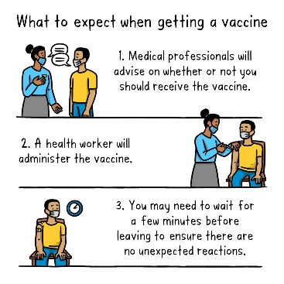

HPV – Post #1 |  | HPV – Post #2 |  | HPV – Post #3 |  | HPV – Post #4
Since there is no screening program for HPV-positive oral cancers, “The vaccine is our current best hope for prevention. Our data underscore the importance of ongoing efforts to increase HPV vaccination rates in the U.S. The entire population will benefit,” said Maura Gillison, M.D., Ph.D., professor of Thoracic/Head & Neck Medical Oncology and co-leader of the HPV-Related Cancers Moon Shot®. Learn more about cancers caused by HPV: https://www.cdc.gov/hpv/parents/cancer.html |  | HPV can cause six types of cancers. HPV vaccination can prevent over 90% of cancers caused by HPV. Learn more about HPV-related cancers: https://www.cdc.gov/hpv/parents/cancer.html |  | HPV is a common virus that can lead to cancer later in life. Getting the HPV vaccine can prevent 92% of HPV cancers. Click here to learn more about HPV vaccine safety and effectiveness: https://www.cdc.gov/vaccines/vpd/hpv/hcp/safety-effectiveness.html |  | Like all vaccines, scientists monitor the HPV vaccine over time to ensure it’s safe and effective. Over 90% of HPV cancers can be prevented through vaccination. Click here to learn more about HPV vaccine safety and effectiveness: https://www.cdc.gov/vaccines/vpd/hpv/hcp/safety-effectiveness.html |  | INVEST Calendar  MAR  National Nutrition Month
Remember to share at least one social media message from each row with your
school community this month.
Other vaccine – Post #1 |  | Other vaccine – Post #2 |  | Other vaccine – Post #3 |  | Other vaccine – Post #4
Do you worry about the ingredients in vaccines? Learn about preservatives, adjuvants, and other vaccine ingredients: https://www.cdc.gov/vaccines/vac-gen/additives.htm |  | Make sure your middle schooler is fully vaccinated to protect them from serious diseases!  #VaccinesWork  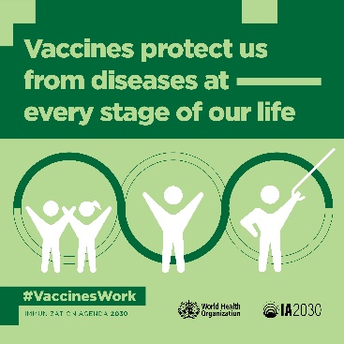 |  | Do you know who recommends vaccines in the U.S.? Learn more about the Advisory Committee on Immunization Practices (ACIP): https://www.cdc.gov/vaccines/acip/committee/role-vaccine-recommendations.html?fbclid=IwAR196GgB-u-RTHuWj3h_g59ngsdpft1Wy0vGxKJ7llY7zMAZOTTgvbraLH0 |  | It’s normal to experience mild to moderate side effects like pain at the injection site, fever, and chills. Good news: They usually go away on their own.  #VaccinesWork

HPV – Post #1 |  | HPV – Post #2 |  | HPV – Post #3 |  | HPV – Post #4
Did you know about the link between HPV and head and neck cancers? Infection with HPV can increase your middle schooler risk of getting head and neck cancers. Learn more about cancers caused by HPV: https://www.cdc.gov/hpv/parents/cancer.html |  | Oropharyngeal cancers — cancers of the throat, tongue, and tonsils — are the most common HPV cancer. The HPV vaccine can help #EndHPVCancers. Get your middle schooler vaccinated at age 11 or 12. Learn more about cancers caused by HPV: https://www.cdc.gov/hpv/parents/cancer.html |  | “I wish I had known it was preventable for everybody. If you care for your kids at all you definitely want to get them vaccinated. I just can’t believe that there isn’t more awareness about it.” Watch this video from John Mark Mason who experienced loss of a loved one due to HPV related cancer: https://vimeo.com/138983945 |  | Almost all cervical cancers are caused by human papillomavirus (HPV), a common virus. There are many types of HPV. Some HPV types can cause changes on a woman’s cervix that can lead to cervical cancer over time. Learn more about cancers caused by HPV: https://www.cdc.gov/hpv/parents/cancer.html |  | INVEST Calendar  APR  World Immunization Week (April 24–30)
Remember to share at least one social media message from each row with your
school community this month.
Other vaccine – Post #1 |  | Other vaccine – Post #2 |  | Other vaccine – Post #3 |  | Other vaccine – Post #4
Immunization reaches more people than any other health service, connecting families with health care systems, reducing strain on hospitals and ensuring everyone has access to the care they need.​  #VaccinesWork to Bring Us Closer  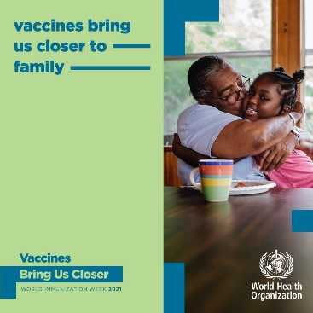 |  | Vaccines are helping eliminate diseases in our communities, making them vital to a closer world.  #VaccinesWork to Bring Us Closer  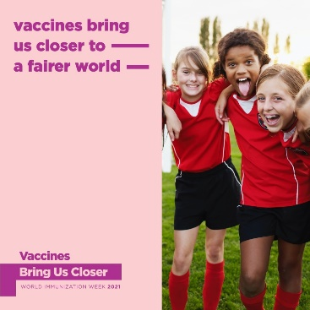 |  | Did you know how vaccines are manufactured, approved, added to the recommended schedule, and how vaccine safety is continuously monitored? Learn more: https://www.cdc.gov/vaccines/parents/infographics/journey-of-child-vaccine-h.pdf |  | Having a doctor's office as the routine place of healthcare for your middle schooler’s health is important to track their health and get all the vaccines on time. Make it your priority! #CallYourPediatrician  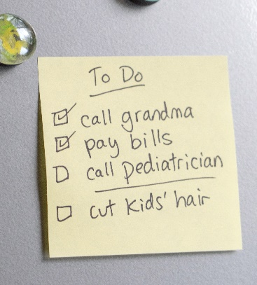

Version for NORTH CAROLINA
HPV – Post #1 |  | HPV – Post #2 |  | HPV – Post #3 |  | HPV – Post #4
HPV is very common: 4 out of 5 people will get HPV in their lifetime. Protect your middle schooler with the HPV vaccine.  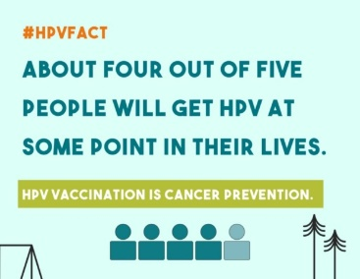 |  | The HPV vaccine protects your middle schooler from six types of cancer in the future. Vaccinate them now!  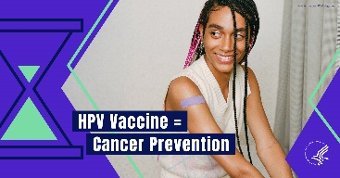 |  | Over 80% of people will be infected by HPV at some point in their life. While some HPV infections may not cause harm, there are a few that can hurt us and our loved ones. The most harmful HPV types cause cervical, anal, oral, penile and other deadly cancers. The good news is that there are solutions. Learn more about HPV vaccine here: https://www.cdc.gov/hpv/parents/vaccine-for-hpv.html |  | Most parents choose the HPV vaccine for their children. In North Carolina, more than 70% of female teens and 45% of male teens receive the first dose. To protect the next generation through herd immunity, we need to reach as many young adults as possible. The HPV vaccination can protect a generation of North Carolina preteens and teens from cancers caused by HPV. |  | INVEST Calendar  MAY  National Children’s Mental Health Awareness Day (May 7)
Remember to share at least one social media message from each row with your
school community this month.
Other vaccine – Post #1 |  | Other vaccine – Post #2 |  | Other vaccine – Post #3 |  | Other vaccine – Post #4
Did you know that the FDA holds public meetings to discuss vaccines before issuing an authorization or approval? Learn more: https://go.usa.gov/xsdy2 #VaccineReady  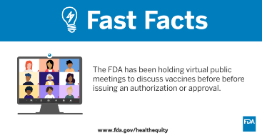 |  | Meningococcal disease is very serious and can even be deadly. Protect your middle schooler through vaccination today!  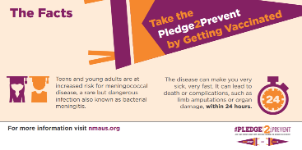 |  | Vaccinate your middle schooler to protect them and loved ones around them!  #VaccinesWork  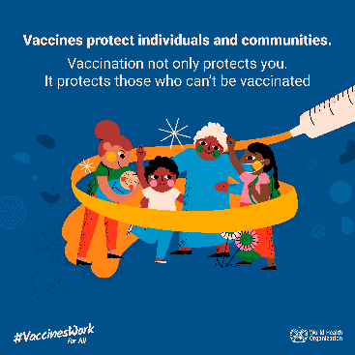 |  | Vaccines undergo many tests to ensure they are safe and effective!  #VaccinesWork  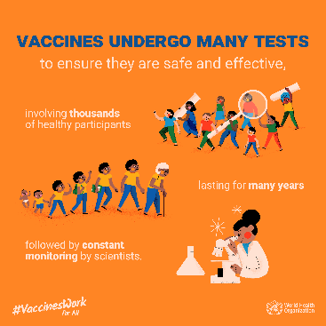

Version for SOUTH CAROLINA
HPV – Post #1 |  | HPV – Post #2 |  | HPV – Post #3 |  | HPV – Post #4
HPV is very common: 4 out of 5 people will get HPV in their lifetime. Protect your middle schooler with the HPV vaccine. |  | The HPV vaccine protects your middle schooler from six types of cancer in the future. Vaccinate them now! |  | Over 80% of people will be infected by HPV at some point in their life. While some HPV infections may not cause harm, there are a few that can hurt us and our loved ones. The most harmful HPV types cause cervical, anal, oral, penile and other deadly cancers. The good news is that there are solutions. Learn more about HPV vaccine here: https://www.cdc.gov/hpv/parents/vaccine-for-hpv.html |  | Most parents choose the HPV vaccine for their children. In South Carolina, more than 70% of teens receive the first dose. To protect the next generation through herd immunity, we need to reach as many young adults as possible. The HPV vaccination can protect a generation of South Carolina preteens and teens from cancers caused by HPV. |  | INVEST Calendar  MAY  National Children’s Mental Health Awareness Day (May 7)
Remember to share at least one social media message from each row with your
school community this month.
Other vaccine – Post #1 |  | Other vaccine – Post #2 |  | Other vaccine – Post #3 |  | Other vaccine – Post #4
Did you know that the FDA holds public meetings to discuss vaccines before issuing an authorization or approval? Learn more: https://go.usa.gov/xsdy2 #VaccineReady |  | Meningococcal disease is very serious and can even be deadly. Protect your middle schooler through vaccination today! |  | Vaccinate your middle schooler to protect them and loved ones around them!  #VaccinesWork |  | Vaccines undergo many tests to ensure they are safe and effective!  #VaccinesWork

